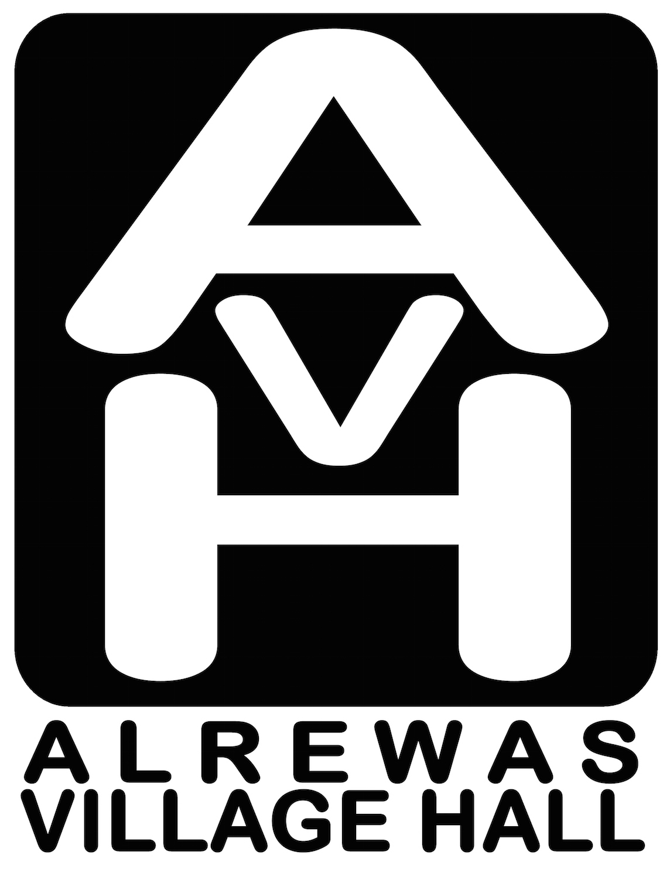
Registered Charity Number: 522598

Alrewas Village Hall Refurbishment

Work has now started on the much-awaited Alrewas Village Hall refurbishment. Alrewas Village Hall is owned by the village and at over one hundred years old plays a pivotal role in the community. Although the original building is sound the extension added in the 1970s is well past its sell-by date.

The initial part of the work will see the toilet block, store room and back section of the kitchen demolished. This will be followed by extensive repairs to the roof. Local builders RJK Construction (Midlands) Ltd are carrying out the work. RJK is run by Richard Kirkland who was born and raised in the village and is “delighted to be working on this project to ensure the future of the hall”. Both he and his father, Ian Kirkland, who works with his son, were apprenticed as craftsmen by village builders. Once the demolition has been completed work will start on building the new toilet, flexible space within the old hall foyer area, kitchen and new annex. It is anticipated that the work will take around 26 weeks.

The Alrewas Village Hall Management Committee would like to thank the community for supporting our fund-raising programme which has worked hard for several years to raise the necessary funds.

Alrewas Village Hall refurbishment is being sponsored by: Lafarge-Tarmac, through Derbyshire Environmental Trust, Alrewas Parish Council, Staffordshire County Council, Lichfield District Council.

We would also like to thank the following members of the community who have given, free of charge, many hours of their professional time to help us through the hugely complex planning and tendering process over the past few years. We couldn’t have done it without them!

Dave Crump of Greenwoods Projects, Lichfield.
Lyndon Glancy of Glancy Nichols Architects, Birmingham.
Debbie Glancy of Alrewas Architecture.

If you have any queries about the building please contact Peter Ralley (790054 or peter@rali.org.uk) who is acting as liaison between the committee and the building contractors, RJK Construction (Midlands) Ltd.

You may wish to follow the progress on the hall website at www.alrewas-villagehall.co.uk where we will be posting photographs and film as the work progresses.

Peter Ralley
Vice-Chair Alrewas Village Hall Management Committee

